**TEAM_ID: PNT2022TMID50401**

Installing python package

**Step 1:**open the anaconda navigator. In the star menu

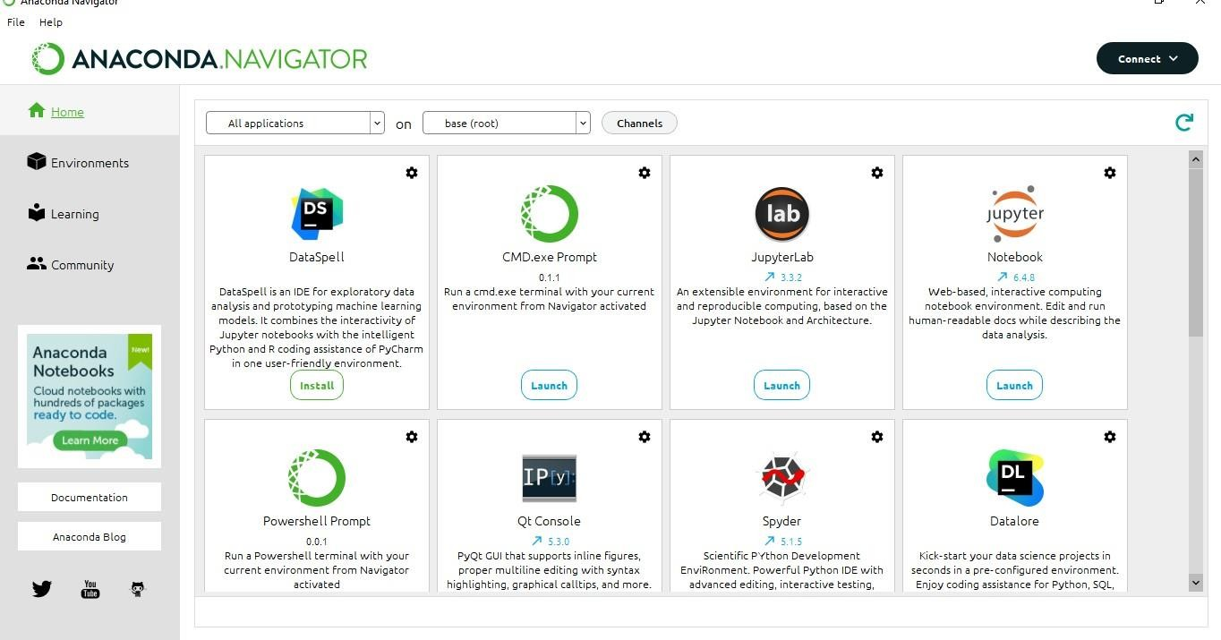

Step 2: open the CMD.exe prompt

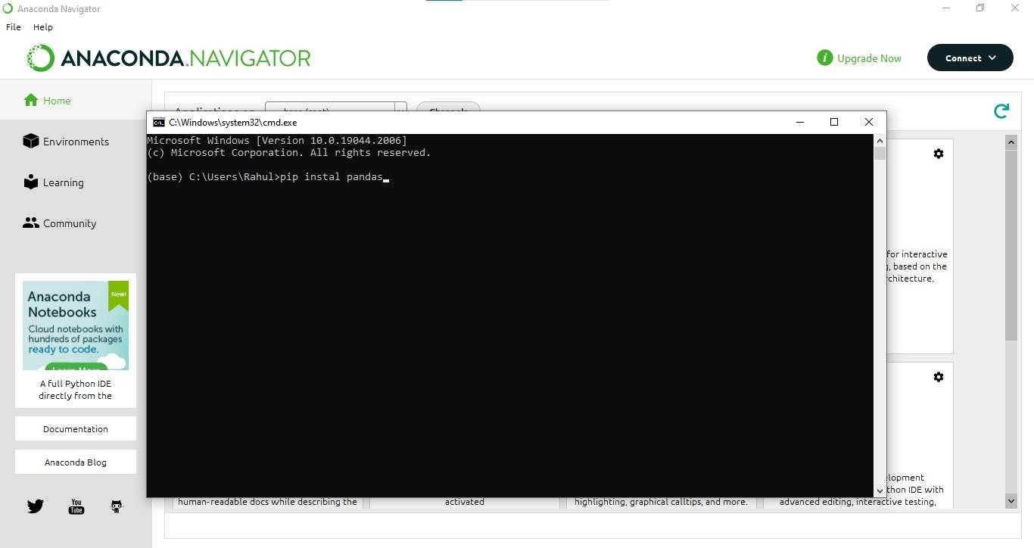

**Step 3**: install the **NUMPY** package .To enter the **numpy**

package enter the command in the CMD.exe Command :**Pip install numpy**

# NUMPY :

Numpy: This package is used to perform numerical computations. This package is pre-installed in anaconda . NumPy is used for working with arrays. NumPy is short for "Numerical Python

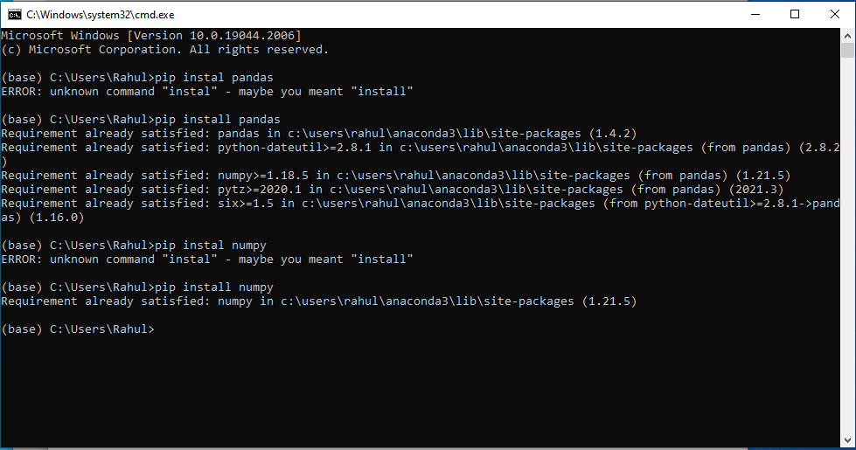

**Step 4**: install the **pandas** package . To enter the **pandas**

package enter the command in the CMD.exe Command: **Pip install pandas**

# Pandas :

Pandas is one of the most widely used python libraries in data science. It provides high-performance, easy to use structures, and data analysis tools. This package is pre-installed in anaconda. is an open-source library that is built on top of NumPy library. It is a Python package that offers various data

structures and operations for manipulating numerical data and time series. It is mainly popular for importing and analyzing data much easier. Pandas is fast and it has high-performance & productivity for users.

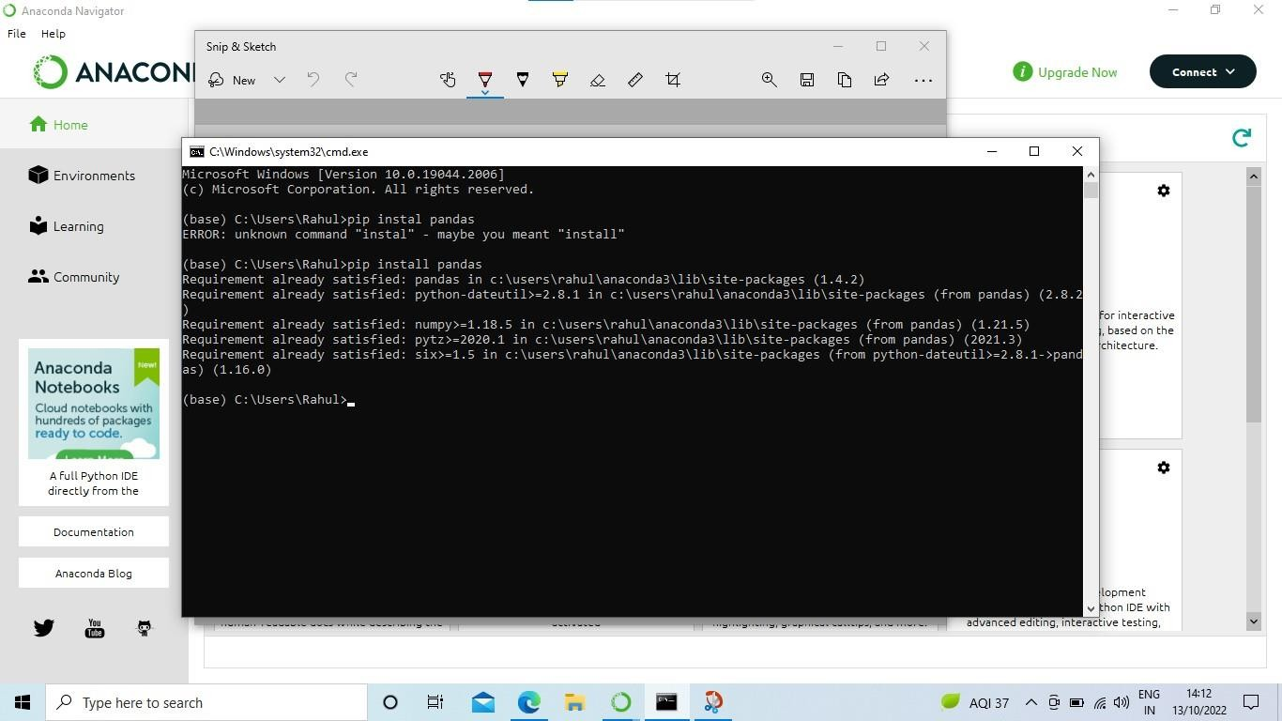

**sStep 5**: install the **Matplotlib** package .To enter the

**Matplotlib** package enter the command in the CMD.exe

**Command:** Pip install Matplotlib

# Matplotlib :

Matplotlib is a comprehensive library for creating static, animated, and interactive visualizations in Python. This package is pre-installed in anaconda . Matplotlib is an amazing visualization library in Python for 2D plots of arrays. Matplotlib is a multi-platform data visualization library built on NumPy arrays and designed to work with the broader SciPy stack. It was introduced by John Hunter in the year 2002.

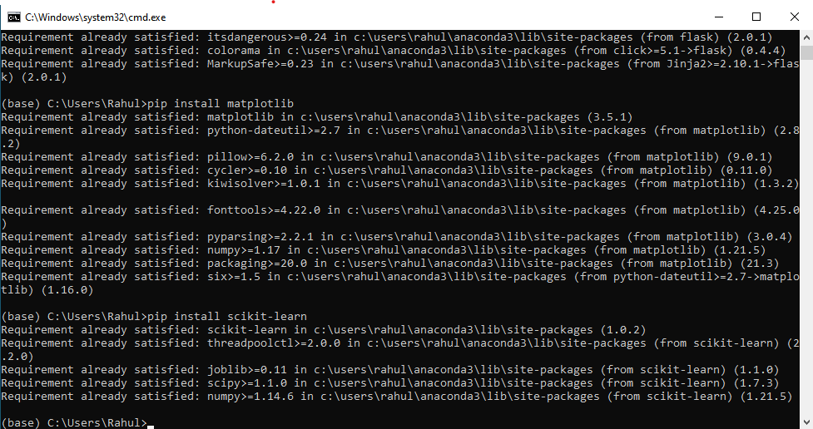

**Step 6**: install the **Scikit-learn** package . to enter the **Scikit- learn** package enter the command in the CMD,exe

**Command:** Pip install Scikit-learn

# Scikit-learn :

This is a machine learning library for the Python programming language. This package is pre-installed in anaconda.

* Scikit learn in python is mostly used in python for focusing on the modeling. It simply focused on modeling not focused on loading the data.



**Step 7**: install the **Flask** package . to enter the **Flask** package enter the command in the CMD,exe

**Command:** Pip install Flask

# Flask :

**Flask is a lightweight WSGI web application framework** Flask is a web application framework written in Python. Armin Ronacher, who leads an international group of Python enthusiasts named Pocco, develops it. Flask is based on Werkzeug WSGI toolkit and Jinja2 template engine. Both are Pocco projects.